**di Lenardo — Venice**

<2 figures, 1 table>

**Venice Time Machine: A Methodology for Mapping Urban History**

di Lenardo, I. and Kaplan, F.

This article discusses the methodology used in the Venice Time Machine project (http://vtm.epfl.ch) to reconstruct a historical geographical information system covering the social and urban evolution of Venice over a period of 1,000 years. Given the time span considered, the project used a combination of sources and a specific approach to align heterogeneous historical evidence into a single geographic database. The project is based on a mass digitization project of one of the largest archives in Venice, the *Archivio di Stato*. One goal of the project is to build a kind of ‘Google map’ of the past, presenting a hypothetical reconstruction of Venice in 2D and 3D for any year starting from the origins of the city to present-day Venice.

Venice is an extremely relevant case study for such an enterprise for at least two reasons. Its transformations are well documented by a large number of sources (numerous historical maps, huge administrative documents, etc.). Its evolution has essentially been ‘organic’ in the sense that most of the urban transformations have left visible traces, and in many cases the original shape of the city has not changed too much. In this article, we demonstrate how sources are used to reconstruct a dense network of information about Venice covering the 1,000-year period.

The project uses a large variety of sources, as summarized in Table 1.

The Historical Geographical System (HGIS) is initiated using the most up-to-date information about Venice contained in the ITB (*infrastruttura di dati territoriali di base*), produced by public authorities (Type A sources in our classification). The quality and the resolution of these initial data are crucial for the success of the project.

Going back in time, the most ancient survey that geometrically measured the ground of the city corresponds to the Napoleonic cadaster (1808–1813) drawn in 1808. Along with the Austrian and the Austrian-Italian cadasters, the Napoleonic cadaster is the most ancient ‘geometric intermediate’ plan that can be used to reconstruct footprints of buildings, streets, channels, wells, public monuments, and other important metadata (census information, property and renting, height, functions and conditions of the buildings) (Noizet et al., 2013). Partial surveys archived at the Archivio di Stato and other cartographic sources can be used in addition to the cadasters (e.g., the ‘Combatti’ map of the 19th century, and the ‘Ughi’ of the 18th century) for the planimetries of monumental buildings (B and C sources).

To geo-reference historical maps and align them with contemporary GIS coordinates, one must choose control points homologous between the raster and the vector files (Figure 1). This is a crucial moment of the analysis, a process that needs a significant knowledge of cartographic conventions, both in terms of drawing and historical notions (Gregory et al., 2001). Each cartographic source has a certain number of peculiarities linked with the city history, the 2D architectural description, the hierarchical importance of the drawn elements, and different values ​​of granularity in the map design. Cartographic sources of type **B and C** must be constantly crossed with iconic sources of type **D,** documenting thecity through paintings or engravings, and bibliographical sources of type **F** studying Venetian urban history. Combining these sources, we can outline each structural class of elements, reediting different layers for lands, buildings, porticos, bridges, wells, banks, sea sands, public monuments, and so on (Gregory et al., 2001). Good geometric approximation of a diachronic visualization of data until at least the 1729 Ughi map can be achieved using this approach.

For the preceding centuries, some Venetian public institutions have managed to produce very comprehensive, albeit incomplete, documentation of several pieces of the urban structure. All these documents, currently being digitized at the Archivio di Stato di Venezia, provide an indispensable source to perform spatial analysis and introduce other information about every structural element of the city previously chosen.

Another ‘temporal nexus’ of particular importance in the history of the Renaissance cartography is the Jacopo de Barbari bird’s-eye view of Venice, published around 1500 (see Balistreri et al., 2000). This source, which we can include as a general iconographic type D source, is at the same time an excellent document from which one could extract a 2D plan and an accurate 3D reconstruction of the city (Figure 2).Thanks to the realignment of the perspective and an architectural analysis of the elements, conducted ad hoc, we can infer and draw a ‘2D de Barbari map’ and proceed to extend the layers of the HGIS up to the year 1500.

Each structural unit of the GIS is also an entry to a database. The objects are organized hierarchically based on their scale from the largest entity, the laguna, to the footprint of each structure. A list of sources (from type A to F) can be associated to each element, cataloguing all the evidence that could be used to define its structure and the events associated with it.

Events describe all the major changes that affect the structural unit (e.g., construction, renovation, extension, destruction) but also other historical moments (e.g., consecration, property change). Each event is associated with a (potentially fuzzy) time span.

Particular series of administrative documents (type E) are extremely important to complement the other sources. Venice performed a series of tax campaigns in which all Venetians had to spontaneously describe their property (Condizioni di decima). These tax campaigns provide six additional temporal nexus for the years 1514, 1566, 1582, 1661, 1771, and 1740. For each of these years, they play the role of a ‘snapshot’ of the urban structures for the whole city. The main information concerns the owners and tenants of the structural unit, providing a lot of social information about them (name, religion, citizenship, origins, profession, political role, etc.). Other kinds of information present in the archives (death certificates, testaments, inventories, and other notarial acts) can be used to extend the information contained in these snapshots in order to create dense social networks of the past. Spatial queries can be performed, crossing social data with geographic information—studying, for instance, the urban repartitions of foreigners, the organization of particular professions in specific neighborhoods, and so on.

Precise addresses in Venice are linked with the first cadasters. Earlier, administrative documents provided only names or textual descriptions of the places they mentioned. Luckily, most names of most Venetian places have been rather constant in time. The toponomastic services designed in the database allow the transformation of place names into the corresponding geographical structural unit. In cases where names are unknown or absent and only descriptions are present, the database allows for a fuzzy zoning of the hypothetical designated areas. Between 1000 and 1550, most historical evidence is of this kind.

The diversity, quantity, and accuracy of the Venetian administrative documents are unique in Western history. By combining this mass of information, it is possible to reconstruct large segments of the city’s past: complete biographies, political dynamics, and the urban evolution of most Venetian neighborhoods. The documents are intricately interweaved, telling a much richer story when they are cross-referenced. This precise and detailed reconstruction can only be achieved as a collective endeavor.

**Acknowledgements**

The Venice Time Machine is an international scientific program launched by EPFL and the University Ca’Foscari of Venice with the generous support of the Fondation Lombard Odier. About a hundred researchers and students currently collaborate on this program. We would like to thank in particular Oliver Dalang, Melanie Fournier, and Marc-Antoine Nuessli for their work on the historical geographical information system used in the project.

**References**

**Balistreri, T. C., Balistreri, E., Ghion, A. M. and Zanverdiani, D.** (2000). *Venezia città mirabile*. Cierre edizioni. Venezia.

**Gregory, I. N., Kemp, K. and Mostern, R.** (2001). Geographical Information and Historical Research: Current Progress and Future Directions. *Humanities and Computing,* **13**: 7–22.

**Noizet, H., Bove, B. and Costa, L.** (eds). (2013). *Paris de parcelles en pixels*. Presses Universitaires de Vincennes, Paris, http://www.apur.org.

|  |
| --- |
| Type A: Contemporary GIS models (venetian ITB) and 3D scanning data. They constitute the starting point of the modelisation. |
| Type B: Historical maps covering the whole city, sufficiently accurate to be geo-referenced. The most ancient of such representations is the Napoleonian cadaster published in 1808. |
| Type C: Partial cartographic elements used as illustrations of particular administrative documents (S.E.A. series of documents from Archivio di Stato di Venezia). |
| Type D: Iconographic documents such as paintings or engravings of the city. |
| Type E: Primary sources (e.g., tax declarations) and documents describing textually the evolution of the city |
| Type F: Secondary sources (e.g. monographies or articles) studying certain aspects of the evolution of the city. |

Table 1. Six types of sources used in the project.

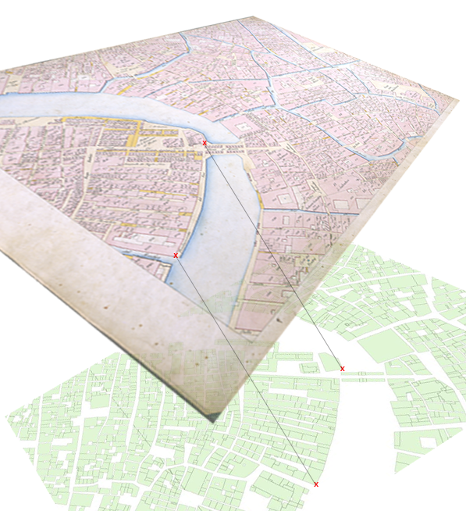

Figure 1. Choice of homologous control points.

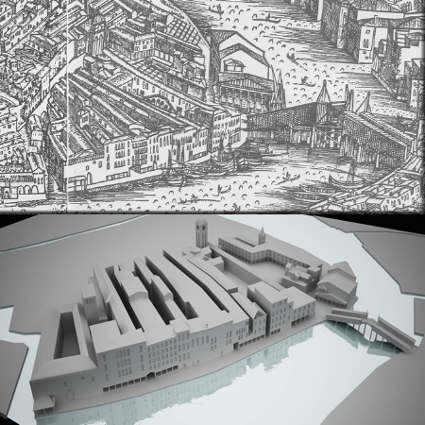

Figure 2. 3D reconstruction from ‘de Barbari’ bird’s-eye view of Venice, 1500.